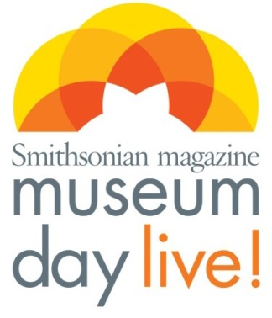
FOR IMMEDIATE RELEASE
Contact: Emily Lilly 561-299-8684

The Butler House Museum Joins Smithsonian Magazine’s
Tenth Annual Museum Day Live!

Free Admission for All Participants Presenting a Museum Day Live! Ticket on September 27, 2014

The Butler House Museum
380 East Hillsboro Blvd
Deerfield Beach FL 33441

The Butler House Museum will open its doors free of charge on Saturday September 27, 2014, as part of Smithsonian magazine’s tenth annual Museum Day Live! A nationwide event, Museum Day Live! offers free admission to visitors presenting a Museum Day Live! ticket at a participating museum or cultural institution.

Inclusive by design, the event represents Smithsonian’s commitment to make learning and the spread of knowledge accessible to everyone, giving museums across all 50 states the opportunity to emulate the admission policy of the Smithsonian museums in Washington D.C. Last year’s event drew over 400,000 participants, and this year’s event expects record-high participation.
The Butler Story
In the early 1920’s the Butler’s came to Deerfield Beach and soon became a prominent and influential farming family in the community. The Butler House which was built in 1925 was bequeath to the DFB Historical Society and in later years was placed on the National Historic Register. Upon the settlement of their estate in the 1980’s, as they desired, a trust was set up to provide scholarships for qualified graduating senior from Deerfield Beach High School, making the high school one of two endowed high schools in the entire United States. Their estate was worth eight million dollars.

The Museum Day Live! ticket will be available to download beginning in August at Smithsonian.com/museumdaylive. Visitors who present the Museum Day Live! ticket will gain free entrance for two at participating venues for one day only. One ticket is permitted per household, per email address. For more information about Museum Day Live! 2014 and a list of participating museums and cultural institutions, please visit: Smithsonian.com/museumday/venues.

About Smithsonian Media
Smithsonian Media comprises of its flagship publication, Smithsonian magazine, as well as Air
& Space, and Smithsonian Media Digital Network. Smithsonian Media is a division of Smithsonian Enterprises, the revenue-generating business unit of the Smithsonian Institution. The Smithsonian Institution is the world's largest museum and research complex consisting of
19 museums and galleries, the National Zoological Park and nine research facilities.
Approximately 30 million people from around the world visit the museums annually.

For information phone: 954-429-0378
www.Deerfield-History.org
Facebook Deerfield Beach Historical Society

